Certificate Participation

Recipient Name
Session Title:

“MCH Policy to Action: Putting the Dietary Guidelines for Americans 2020-2025 into Practice”
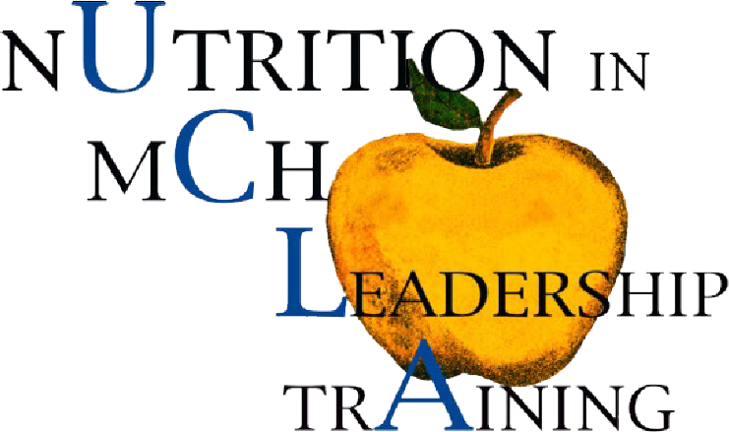 | Presented By:  Dena Herman, PhD, MPH, RD  Director, MCH Nutrition Leadership Training Program  date completed:

