Certificate Participation

Recipient Name
Session Title:

Jeannine Herrick: “Leading from Within: Title V MCH Nutrition Changing Systems of Inequity”
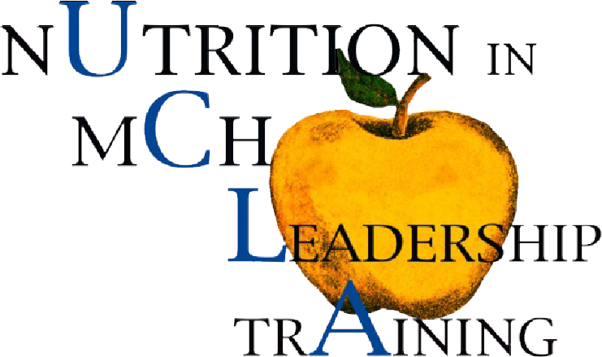 | Presented By:  Dena Herman, PhD, MPH, RD  Director, MCH Nutrition Leadership Training Program  date completed:

