Core Project Team: Chris Mornick, MPH, RD, Washington State Department of Health; Vic Colman and Sophia Reimer, Childhood Obesity Prevention Coalition.
Statewide Coalition Member Organizations: Washington State Department of Agriculture, Office of Superintendent of Public Instruction, Washington State University - SNAP Ed, Seattle Farm to Table, Catholic Charities Food for All Program, Viva Farms in Skagit County, Skagit/Island Head Start and ECEAP, University of Washington Center for Public Health Nutrition; EcoTrust Oregon; Marion Forsman-Boushie Early Learning Center
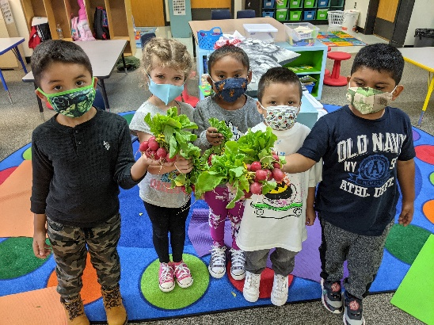
Background/Introduction: In fall 2020, Washington State was awarded a Farm to ECE Implementation Grant (FIG) to strengthen statewide systems that support Farm to ECE. In year 1, our work focused on: building a statewide alliance with diverse membership; integrating Farm to EEC into CACFP; supporting Farm to ECE policies and legislation; developing free online training modules; gathering and disseminating success stories; building a robust website; and increasing equity and diversity, especially for tribal programs. In 2021, we received another year of funding to continue our FIG work.

Methods: Our work is conducted mostly by the core project team with input from the statewide Farm to ECE Alliance and our Farm to ECE Community of Practice (CoP).

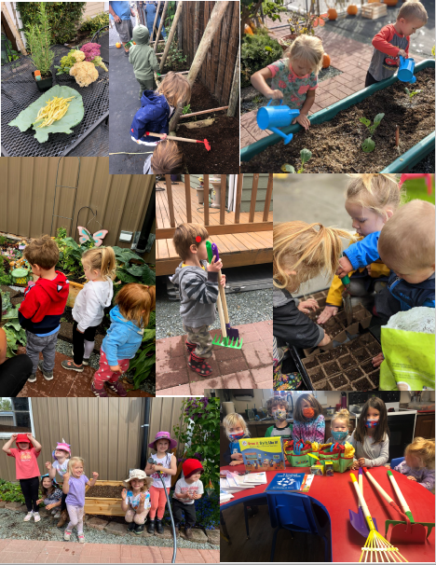
Results/Summary/Discussion: Our year 2 FIG strategies focus on increasing equity, diversity and inclusion by creating unique pages on the website for Spanish language and tribal resources, as well as adding gardening and procurement trainings in English and Spanish. We are also providing direct support and funding to tribal early learning programs to incorporate traditional foods into menus and curriculums. We are also focused on increasing collaborative opportunities at the community and statewide level. Based on feedback from CoP members, we are developing a new member portal on our website that will allow for sharing of information, resources and questions. We are also working closely with other state agencies to incorporate Farm to ECE into existing child nutrition and agricultural programs. To increase multi-state collaboration, we invited EcoTrust Oregon to join our Farm to ECE Alliance. We are also working with EcoTrust and the Oregon Farm to School and School Gardens Network to explore the possibility of a WA/OR Farm to School and ECE Institute. WA and OR were recently accepted into the Vermont FEED 2022-2023 Farm to School Institute Adaptation Program in VT this June.

