Story Sharing Circles

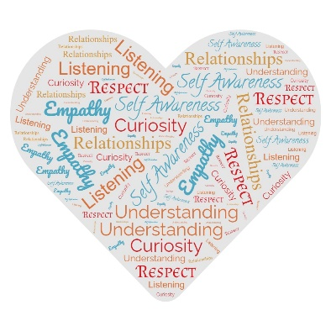
- Round 1: Getting Acquainted
  - Get into your small groups of 3-4 people.
  - Go around the circle, each person introduces themselves using the below prompts*.
  - Each person should share in 2 minutes or less.
  - Allow each person to share without interruptions, comments, or questions.

- I am (2-3 adjectives that describe you)
- I come from…(a place, a feeling)
- I feel awesome when …

- Round 2: Listening for Understanding
  - Go around the circle, each person shares a story related to the below prompt.
  - Each person should share in 3 minutes or less.
  - Allow each person to share without interruptions, comments, or questions.

- Describe a time when you realized you believed in a stereotype that was not true. The stereotype can be about yourself, about a group you are part of, OR a group you are not part of. Describe what happened.

- Flashbacks
- Start with the first person in the circle who shared their story.
- Each person (other than the storyteller) shares a memorable part of the story.
- Share your insight in 15 seconds or less
- Once everyone has shared their insights for the 1st person, go to the 2nd person. Continue sharing until you have had “flashbacks” for everyone in your circle.

- Debrief
- What common themes did you hear from the stories?
- What surprised you?
- What did you learn about yourself?
- What will you do now after having this experience?
- How might you use this technique within your organization and agency?
    - With the community?
    - What prompts might you use?

.
Reference for the session: Deardroff, D. Manual for Developing Intercultural Competencies Story Circles. UNESO, 2020.
*Get Acquainted prompts from: Tapping the Potential of Community Engagement Playbook (pg. 8).

