Leading Equity Work: System Support Mapping
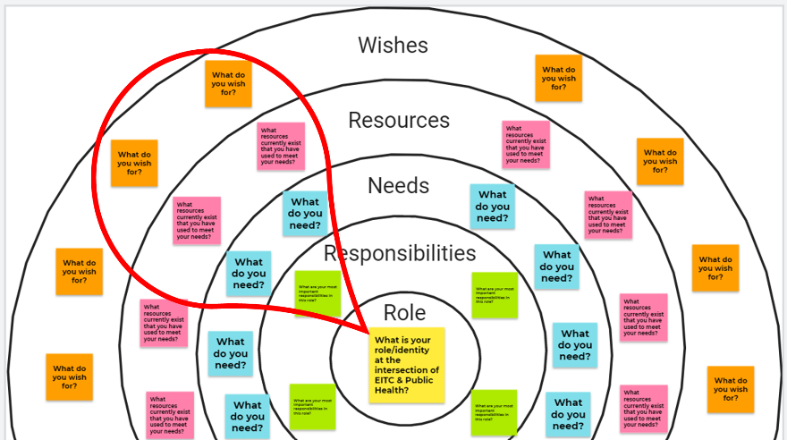
COLOR | Focus Question | Responses
YELLOW | What is your role as an Equity Leader?
GREEN | What are the key responsibilities/tasks?
BLUE | What do you need to succeed?
PINK | What resources are available to fill the need?
ORANGE | What do you wish for?

